**Grounded Worker in Tatooine**



**Javier Jesús Macossay-Hernández**

**EE443 – Introduction to Power Systems**

**University of Southern California**

**Professor Robert Castro**

**Objective**

In this problem, we will be calculating the operating voltage of a bus and the power dissipated using the impedance of the transmission line and the current that flows through the fault. In addition, since George Lucas graduated from USC and the new Star Wars movie is about to come out, I will be honoring him by relating this problem to a Star Wars situation.

**Introduction**

In a galaxy far, far away, Darth Vader had a warfare manufacturing plant in his home planet, Tatooine. Normal production in this plant are drones, lightsabers, and laser guns. After meeting with the Engineering Design and Implementation Team, Darth Vader got a phone call from an operations supervisor: there was a traitor at the workplace. He was a spy. He was part of the rebellion. Darth Vader does not tolerate a betrayal, so he proceeds to follow the Sith protocol for treason. Darth Vader walks down the stairs while yelling at his personal assistant. Once he gets to the production floor, the rebel gets pointed out by the supervisor. The rebel was working on fixing the TIE Series production line without knowing that he was discovered. Suddenly, he feels he is levitating. In less than a fraction of a second, he gets thrown to 30 mile-long three phase delta-configuration Cardinal transmission line connected to one bus, depicted in Figure 1 from Design Case 2. At the same time, Darth Vader ties another three phase Cardinal transmission line to the worker’s feet and grounds it. Even though it is a different galaxy, it is the same universe. Therefore, we share the same physical concepts and reality. Darth Vader, who graduated from the Jedi Knight Academy with a Bachelor of Science in Electrical Engineering with an emphasis in Power Systems, he knew that he was going to create a voltage difference and current was going to flow through the rebel. The transmission line will start to work to its full capacity (1152 A/phase – 3,456 A three phase, according to Los Angeles Department of Water and Power test laboratory’s values) when the rebel gets grounded.

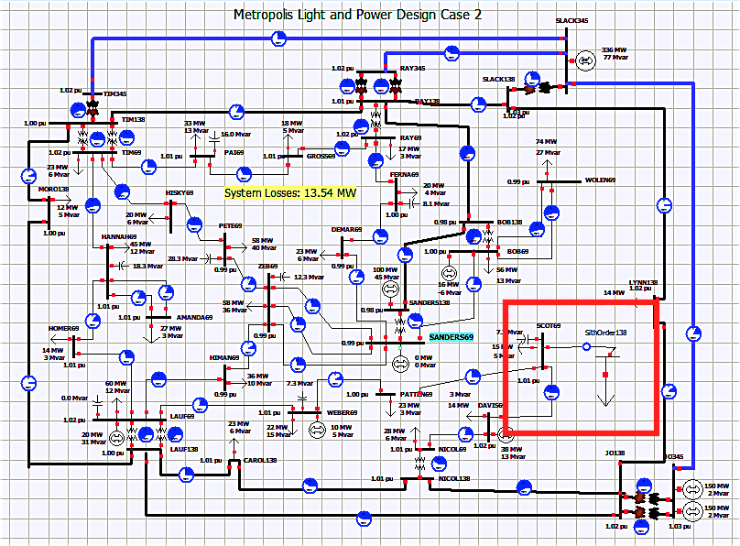

Figure 1: Design Case 2 shows the Power Distribution System in the Manufacturing Plant. The bus, SithOrder138, where the spy will be connected is highlighted.

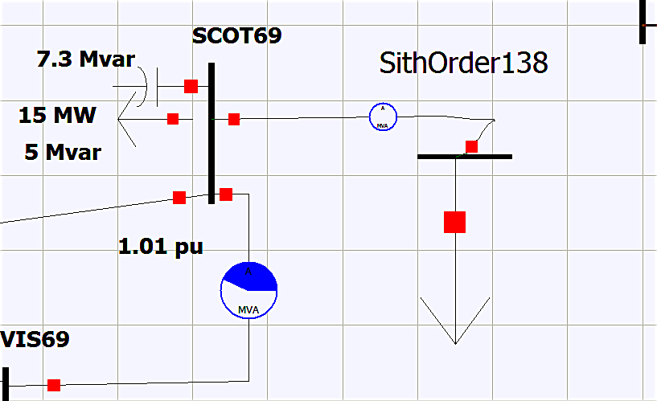

Figure 2: SithOrder138 bus connected to a load. The rebel is represented by the load.

**Methods**

Approach

1. I will begin by finding the GMD and GMR values of the transmission line.
2. Determine the impedance of the system.
3. I will add the rebel’s impedance to the system’s impedance.
4. I will use Ohm’s Law to find the voltage of the bus and the power dissipated by the rebel.

**Calculations**

Assume the below transmission line configuration with a line length of 20 miles.

d = 0.2’ D = 50’

Distance between each conductor d= 0.2’

Distance between each subconductor bundle phase D= 50’

To find the transmission line parameters, the geometric mean diameter (GMD) of the whole system must be found.

GMD = (multiplication of distances between bundles) 1/n, where n = number of bundles

Because there are three phases, then:

GMD = (D * D * 2D)1/3 = (50 * 50 * 100)1/3 = 62.996’

*Cardinal*

Using table A3, DS can be found for each conductor to calculate the geometric mean radius for each subconductor bundle.

DS Cardinal = 0.0402’

GMRø = (DS x d x d)n/ (n^2) where n= number of conductors in each bundle.

GMRø = (0.0402 x 0.2 x 0.2)3/9 = 0.117’/ phase

With GMD and GMRø, L, C, XL, XC, R, Z, and Y can be found.

L = 0.7411 log (GMD/GMRø) mH/mile = 0.7411 log (62.996/0.117) mH/mile

L= 2.02 mH/ mi

C= 0.0388/ (log (GMD/ GMRø)) µF - mile = 0.0388/ (log (62.996/0.117)) µF - mile

C= 0.014207 µF – mi

XL = 2πƒ x L = 2 π * (60) * (0.00202)

XL = 0.76 Ω / mi

XC = 1/ (2πƒ x C) = 1/ (2π * (60) * (0.000000014207))

XC = 0.18671 MΩ / mi

Because the line length is YYYY miles, then the following are true:

XL = 0.76 x 30 miles= 22.8 Ω

XC = 0.18671M x 30 miles = 5.6013 MΩ

R can be found from table A3:

R = 0.0988 Ω/mi at 20ºC for one conductor

Because the sub-conductor bundles have three conductors, the total resistance is reduced as their resistance is paralleled.

R= (1/0.0988+ 1/0.0988 + 1/0.0988)-1 = 0.0329 Ω/mi

Because the line length is 30 miles, then:

R= 0.0329 * 30 miles = 0.987 Ω

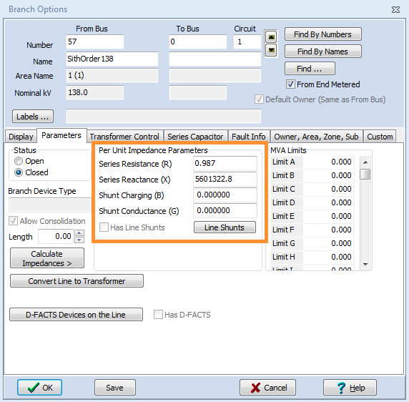

Figure 3: Impedance Parameters of bus SithOrder138

Therefore, Z (impedance) = $\sqrt{R^{2}+X^{2}}$ = $\sqrt{{0.987}^{2}+{(22.8+5601300)}^{2}}$ = 5,601,322.8 Ω

Now, I will add the impedance of the rebel, which is 100,000 Ω.

Ztotal = 5,601,322.8 Ω + 100,000 Ω = 5,701,322.8 Ω

**Results**

Voltagebus = Ifull capacity * Ztotal = 3,456 A * 5,701,322.8 Ω = 19,703,771,596.8 V $≈$ 19.7 GV

Powerdissipated = Ifull capacity2 Ztotal = (3,456 A)2 * 5,701,322.8 Ω = 68,096,234,638,541 W $≈$ 68.09 TW

Darth Vader wanted to show to other workers the consequences of betraying the Dark Side.

**Discussion**

This problem has basic physical concepts (Ohm’s law), power system concepts (GMD, GMR, buses), and the PowerWorld simulation. In addition, it is a creative and innovative manner of applying technical knowledge.